Compilation and Running

Structure of a C Program:
C Program is devided into the Individual Blocks of Code.
The Individual Blocks are called as Functions.

main() /* Starting of a program */
{
Declare Data
Executions
} /* Ending of a program */

C program should piled in order to check whether it performs the required task.

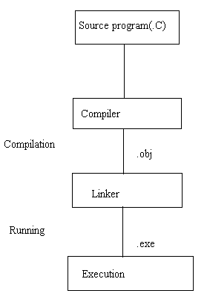

Compilers:
Which transulates the Source program (.C) into Object file (.obj)

Types of compilers:
Microsoft, Boreland (Turbo C2, Turbo C3)

Turbo C2:
Using an Integrated Development Environment (IDE) we develop a C Program.
C:\Turboc2\Tc.exe

In IDE, we develop C Source programs and we can run those programs.

Compilation: Alt + F9
or Alt + C + enter

Running: Ctrl + F9
or Alt + R + enter

Result: Alt + F5

